Product features and functionalities

The goal of the PetBook app is to create a community-focused platform. The app should allow users to create profiles for their pets, each pet having its own unique profile. You should be able to post photos of your pet and also interact with other pet profiles by liking and commenting on their posts and following their profiles, similar to other social media apps like Facebook and Instagram. You will have a feed page where you can see what the profiles you follow have posted and also a discovery page where you can see posts made by profiles which you don’t follow, in order to interact and engage with new content. There will be a dedicated area where users can share blog posts. Both photos and blog posts should allow for custom tags, which the user can define, this enables other users to efficiently search for posts they are interested in on the platform.

|  |  |
| --- | --- |
| Feature | Functionalities |
| Pet Profiles | * create and manage unique pet profile for each pet |
| Account | * create account * login/logout |
| Content Posting | * post photos * post blog posts * delete photos * delete blog posts * add tags to blog post |
| Interaction with Content | * follow other users * like posts * comment on posts * like comments * delete comments * receive notifications of post interaction * edit comments |
| Feed Page | * visualize posts from followed pet profiles |
| Discovery Page | * visualize posts from not-followed pet profiles |
| Search | * look up content based on tags * look up content based on blog title * look up users or pets by name |
| Chat | * send messages * send pictures |

* Features & functionalities mindmap

<https://lucid.app/lucidspark/1b6798d6-6b83-4a19-a91b-d70503ddf667/edit?viewport_loc=-5150%2C-1343%2C6417%2C3169%2C0_0&invitationId=inv_80129917-d073-4209-953d-9931eef5fbcc>

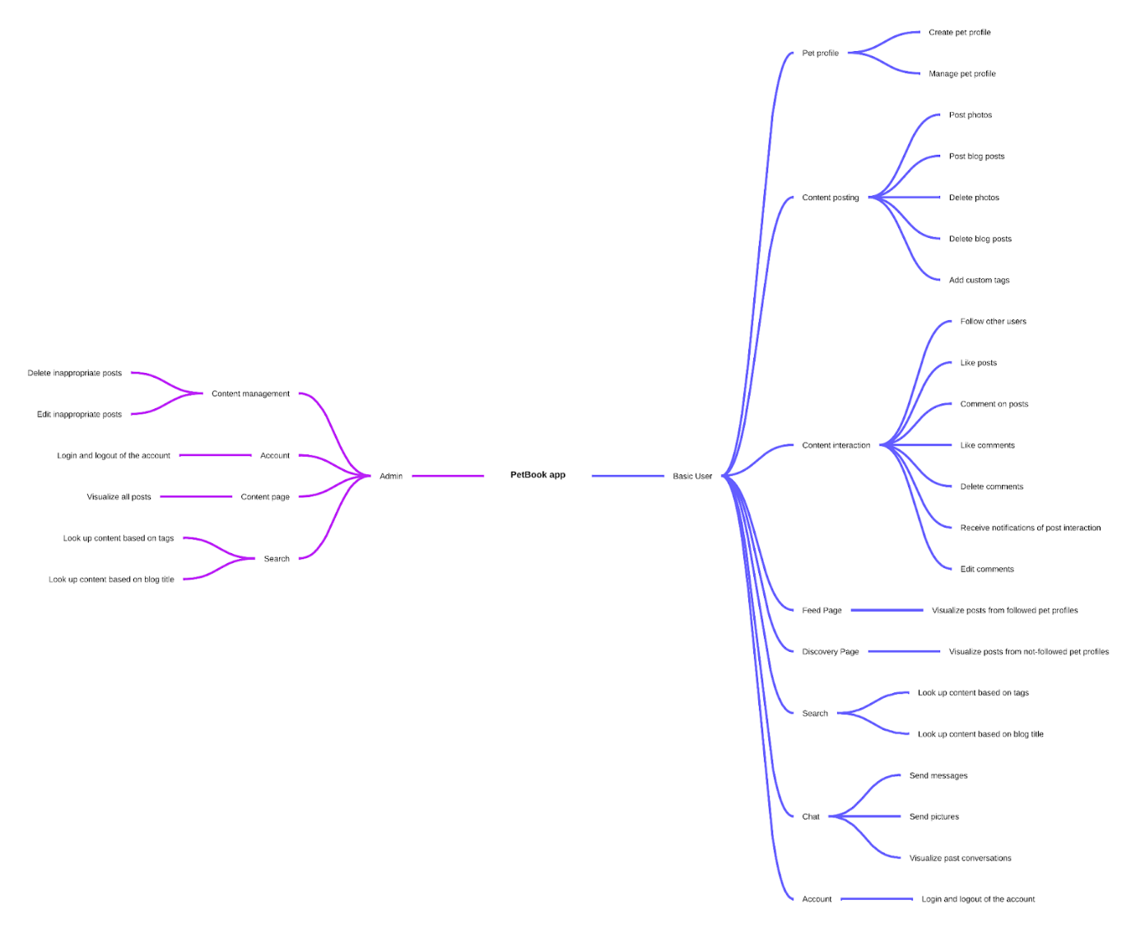

* Entities and operations

|  |  |  |  |  |
| --- | --- | --- | --- | --- |
|  | Create | Read | Update | Delete |
| PetAccount | - user  - form | - user, admin  - account page | - user, admin  - form | - user, admin  - button |
| PhotoPost | - user  - form | - user, admin  - card on feed | - user, admin  - form | - user, admin  - button |
| BlogPost | - user  - form | - user, admin  - card on blog page | - user, admin  - form | - user, admin  - button |
| PostLike | - user  - button | - user, admin  - counter under the post |  | - user, admin  - button |
| BlogPostLike | - user  - button | - user, admin  - counter under the post |  | - user, admin  - button |
| Comment | - user  - form | - user, admin  - card under the post | - user, admin  - form | - user, admin  - button |
| CommentLike | - user  - button | - user, admin  - counter under the comment |  | - user, admin  - button |
| ApplicationUser | - user  - form | - user, admin  - account page | - user, admin  - form | - user, admin  - button |
| Tag | - user  - inside the blog form | - user, admin  - inside the blog card | - user, admin  - inside the blog update form | - user, admin  -  inside the blog update form |
| Message | - user  - chat view | - user  - chat view |  |  |

* Integration points

We use SQLServer for the database, which communicates with the app through the Entity Framework, which is a Microsoft solution for building a clean, portable, and high-level data access layer.

* Roadmap

